

CSA0501-DATABASE MANAGEMENT SYSTEMS

LAB EXPERIMENTS DATE: 29/07/2026

EXPERIMENT 12 – Simple Programming using WHILE and REPEAT

AIM: To learn how to use MySQL WHILE and REPEAT loop statements to execute a block of code repeatedly based on a condition.
PROCEDURE:
- Select the required database using the USE command.
- Create a function using the WHILE loop.
- Execute the function and display the result using SELECT.
- Create another function using the REPEAT loop.
- Execute the function and display the result.
- Verify that the loops execute according to their conditions.
- Confirm successful execution of both programs.

PROGRAM:

1 . WHILE LOOP

Write a function that uses WHILE to build a string repeatedly until x becomes greater than 5.

DELIMITER //

CREATE PROCEDURE pet_while_loop()

BEGIN

DECLARE x INT;

DECLARE str VARCHAR(255);

SET x = 1;

SET str = '';

WHILE x <= 5 DO

SET str = CONCAT(str,

CASE x

WHEN 1 THEN 'Rudra,'

WHEN 2 THEN 'Snoofy,'

WHEN 3 THEN 'Chichu,'

WHEN 4 THEN 'Hulk,'

WHEN 5 THEN 'Battu,'

END);

SET x = x + 1;

END WHILE;

SELECT str;

END //

DELIMITER ;

OUTPUT:

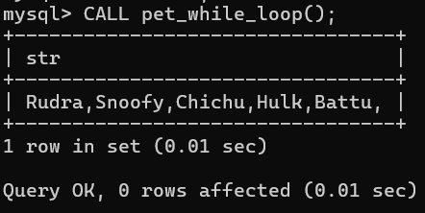

2 . REPEAT LOOP
Write a function using REPEAT which repeats until income becomes greater than or equal to 4000.
DELIMITER //
CREATE PROCEDURE repeat_pet()
BEGIN
DECLARE x INT;
SET x = 0;
REPEAT
SET x = x + 5;
UNTIL x >= 20
END REPEAT;
SELECT x;
END //
DELIMITER ;
OUTPUT:

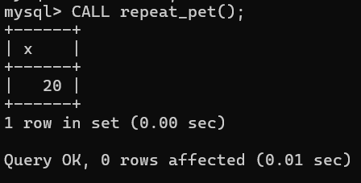

RESULT: Thus the Simple programming exercise using (REPEAT, WHILE )executed successfully.

